DATA RECONCILIATION TASK
Source tables were loaded to Source System Database (dwh_src_hw_db) and checked:
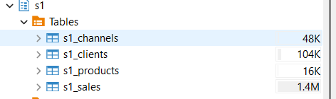
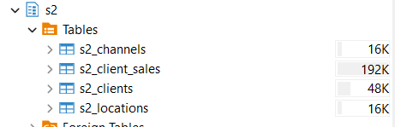
Landing tables, DWH tables and DM table were loaded to Target System Database(dwh_hw_db) and checked:
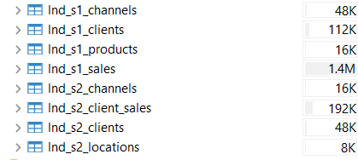\
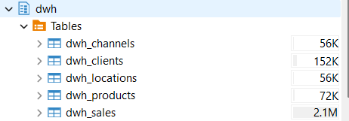
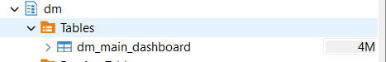
In target database extension to connect to Source System Database was established.
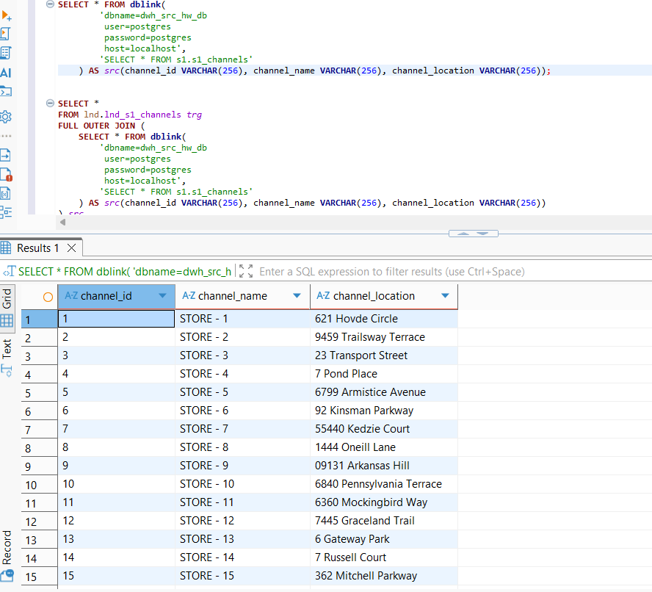
Then to compare rows between dedicated tables of 2 DBs the script mentioned in the screenshot was executed. The script initializes the core logic for the automated data reconciliation layer. By setting up a FULL OUTER JOIN between the target landing table (lnd.lnd_s1_channels, aliased as trg) and the remote source subquery (src), the pipeline ensures that no data omissions (such as missing rows or orphaned keys on either side) are overlooked during the audit phase.
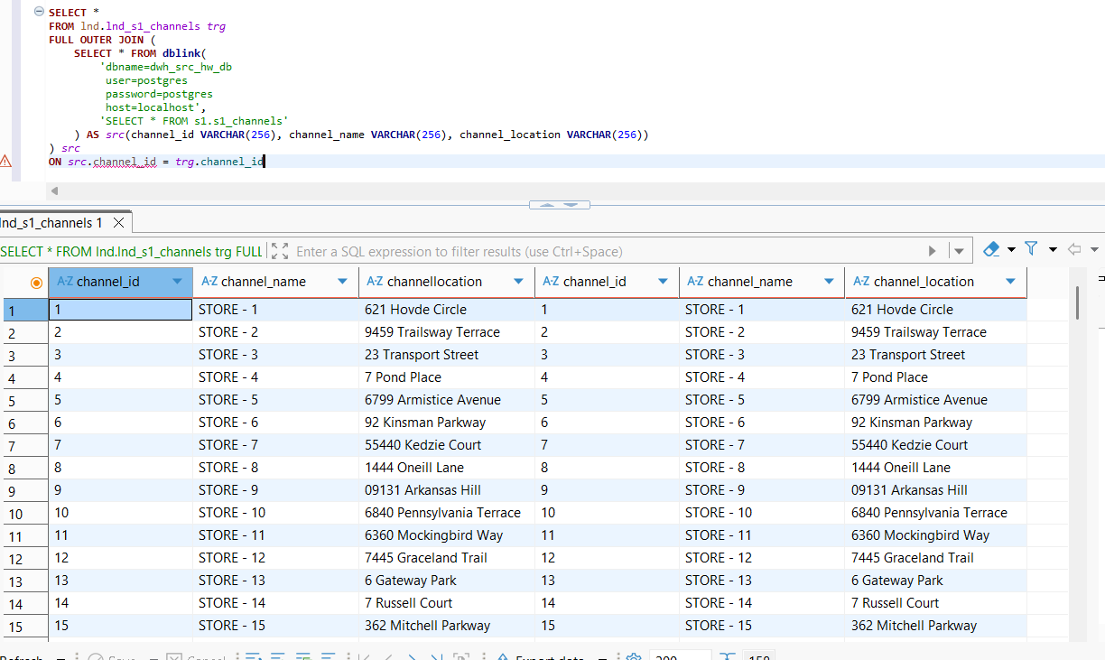
The raw output is not very readable or convenient for quickly identifying mismatches.To improve this, the query was wrapped in a result CTE and classify rows by clear reconciliation statuses, making it easier to spot differences:
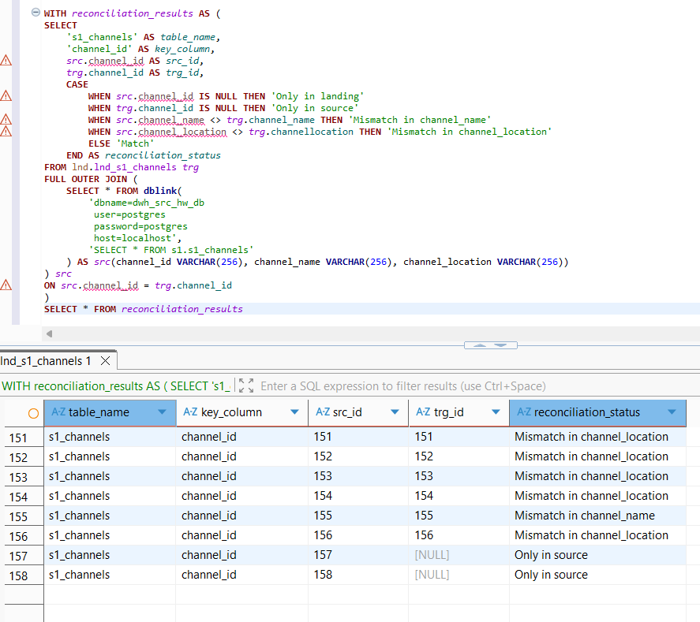
Table for tracking the reconciliation results were created:
CREATE TABLE lnd.reconciliation_results (
table_name VARCHAR(256),
key_column VARCHAR(256),
src_id VARCHAR(256),
trg_id VARCHAR(256),
reconciliation_status VARCHAR(256)
);
Based on the script for s1_channels , the query was rewritten for other table from s1_source. The final result of the table lnd.reconciliation_results:
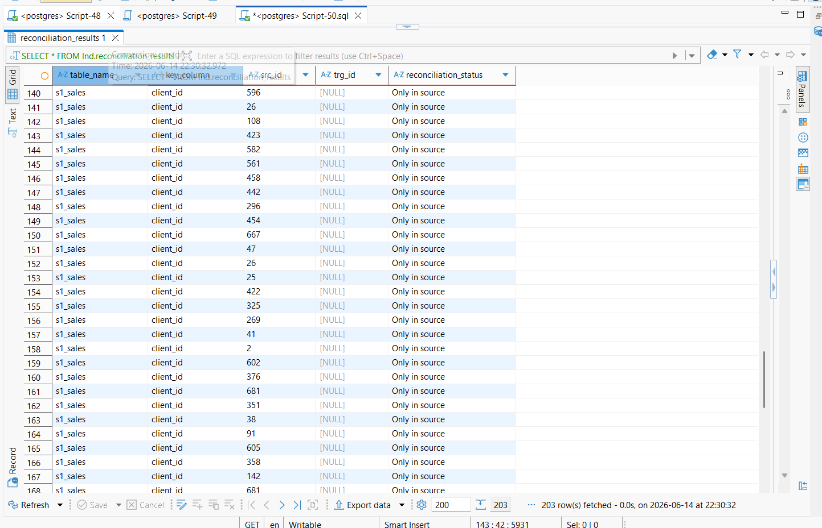
The full script with comments can be found in Python_reconciliation.sql file.
Same script was performed for s2_source. The final result of the table lnd.reconciliation_results:

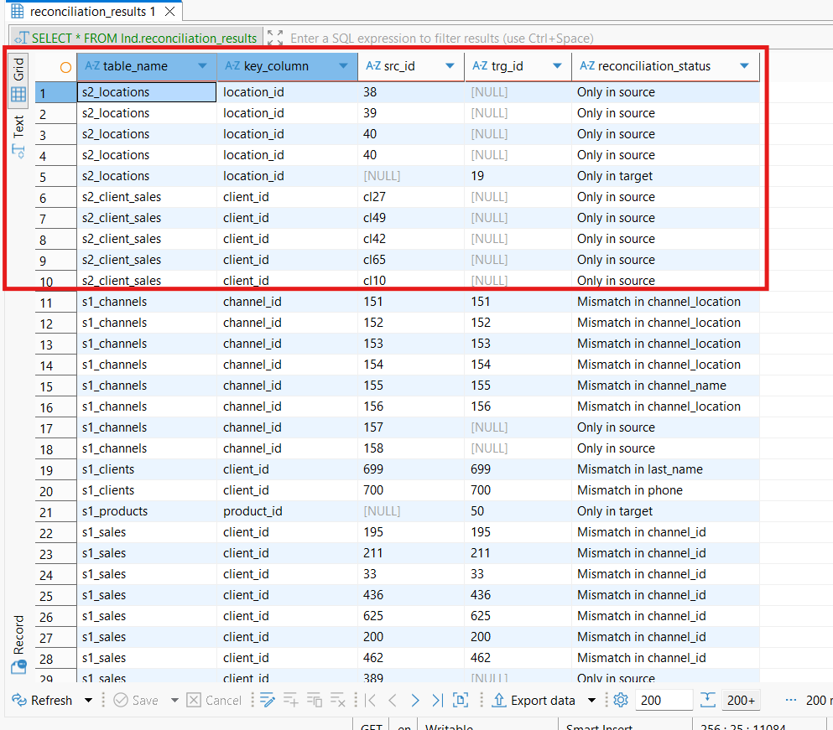
The full script with comments can be found in Python_reconciliation.sql file.
To transition from low-level row discrepancies to high-level Data Quality (DQ) metrics, an aggregation script was deployed. This query groups distinct system failures by their target entities and status types while evaluating the mathematical weight of each error category relative to the total log volume.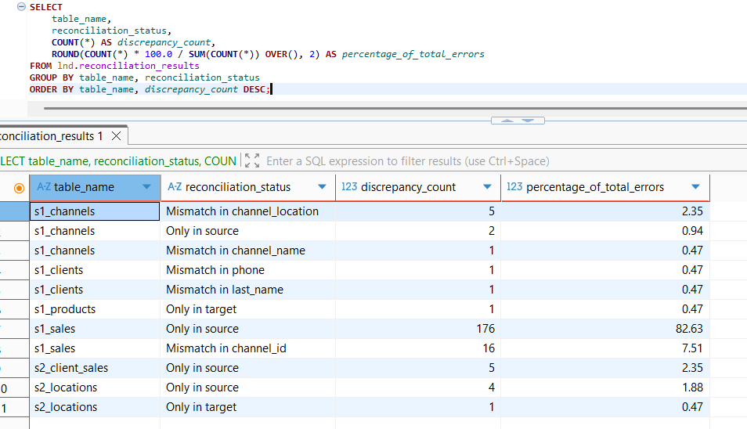
Summary of Reconciliation Results
- Most Discrepancies
  - s1_sales: 192 total issues (176 rows Only in source + 16 Mismatch in channel_id). This accounts for 90.14% of all data quality incidents in the entire pipeline, representing a critical volume drop during mass ingestion.
- Least Discrepancies:
  - s1_products and s1_clients: Only 1–2 minor issues per table (such as single attribute mismatches like Mismatch in phone or a single orphaned row Only in target). These entities show the highest level of consistency across the DWH layers.

